

**G. M. R. H. & R. C.’s**

**Accredited by NAAC with B++** and **ISO 9001:2015 Certified Institute**

## Sant Gajanan Maharaj College of Engineering,

**Mahagaon, Site: Chinchewadi, Tal-Gadhinglaj, Dist- Kolhapur, 416503**

**Department of Electronics and Tele-communication**

### SYNOPSIS

**“Three-Phase Ac voltage Monitoring using Arduino”**

**Submitted By,**

|  |  |  |
| --- | --- | --- |
| **Sr. No.** | **Name of Student** | **Roll No.** |
| 1. | Mr. Roshan Ashok Avadan | 01 |
| 2. | Mr.Shubham Dayanand Powar | 07 |
| 3. | Mr.Sushilkumar Mashnu Parase | 09 |

**Prof. A. B. Farakte Dr. S.H.Sawant** Guide **&** HOD (E&TC)Principal

Academic Year 2022-23

**SYNOPSIS**

### Name of the Course : Third Year B.Tech.(Electronic and Tele-communication)

* **Name of the Students :** 1.Roshan Ashok Avadan.

2.Shubham Dayanand Powar.

3.Sushilkumar Mashnu Parase.

* **Date of Submission of Synopsis**: 15/05/2023

### Name of the Guide: Prof.A.B.Farakte(Sir).

* **Mini Project : “Three-Phase Ac voltage Monitoring using Arduino.”**

## Abstract

# The 3-Phase AC Voltage Measurement using Arduino project aims to develop a reliable and cost-effective solution for measuring and monitoring voltage levels in three-phase alternating current (AC) systems. By utilizing an Arduino microcontroller, voltage sensors, and appropriate software, the project enables accurate measurement and analysis of three-phase voltage parameters.

The 3-Phase AC Voltage Measurement using Arduino project provides a versatile and accessible solution for monitoring and analyzing three-phase AC voltage levels. Its affordability, ease of implementation, and flexibility make it an ideal choice for both educational purposes and practical applications in various industries.

# Relevance

The project of measuring 3-phase AC voltage using Arduino is relevant in various industrial and residential applications where accurate voltage monitoring is required. Here are a few reasons why this project is relevant:

Power Quality Monitoring: Voltage fluctuations or imbalances in a 3-phase AC power system can cause damage to electrical equipment or disrupt their proper functioning. By monitoring the voltage levels in each phase, this project enables power quality analysis and helps identify any abnormalities or potential issues.

# Preface

This project aims to provide you with a comprehensive understanding of how to monitor and measure the voltage levels of a 3-phase AC power system using the popular Arduino microcontroller platform. Whether you are a hobbyist, a student, or an electronics enthusiast, this guide will equip you with the necessary knowledge and skills to undertake this exciting project.

The world heavily relies on three-phase power systems for efficient electricity distribution, making it crucial to monitor and maintain stable voltage levels in these systems. With the help of Arduino and a few additional components, you can build a cost-effective and reliable voltage measurement system that offers real-time monitoring capabilities.

# Literature survey

|  |  |  |
| --- | --- | --- |
| Sr.No. | Name of the Literature | Output |
| 1 | Hu Ma et al | considered a 3-phase 3-level Vienna rectifier and combined a predictive control algorithm. They proposed a synthesized algorithm of enhanced sliding mode varying system control and direct power control deadbeat prediction. The control algorithm adopted a predictive direct power regulation method. |
| 2 | He Li et al | suggested a technique of Decoupled Double Synchronous Reference Frame Phase-Locked Loop (DDSRF-PLL). The transformation of grid voltage on positive and negative reference was performed, and the de-coupling network was designed to split fundamental positive and negative series elements, and the effect of cross-coupling 2ω harmonics is effectually mitigated. |
| 3 | Cheng and Huang | identified the problems of voltage oscillation at neutral point and zero-crossing deformity on 3φ current in Vienna rectifier. A less midpoint voltage oscillation and less deformity at zero current were designed for greater operation of Vienna filter. The balancing voltage at midpoint was attained by fine tuning of positive and negative operational period through less valued vector |

# Porposed work Problem statement

* To design monitoring device that can measure AC voltage using Arduino.
* **Display module:**

This module will receive data from the processor and calculate the voltage. The voltage will be displayed on LCD.

# Details

**BLOCK DIGRAM:**

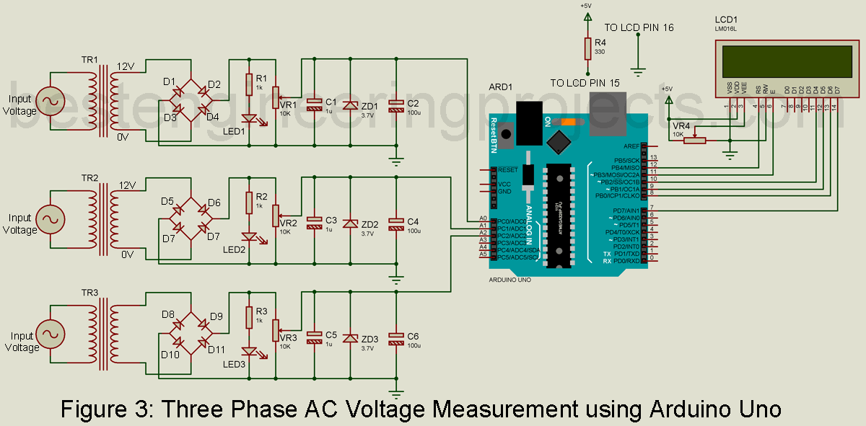

1. Can measure AC voltage of any amplitude.

2. Show individual phase voltage.

3. LED indication for individual phase voltage.

4 .For the protection of the control board (Arduino Board), a variable resistor is used i.e. output voltage must not be more than 4.5V even when Zener diode burnout.

1. **Approximate Expenditure:** Rs. 1500/-
2. **References**

# Book: "Arduino Cookbook" by Michael Margolis - This book provides practical examples and projects for Arduino programming, including sections on voltage measurement and AC circuits.

# Book: "Arduino Projects for Amateur Radio" by Jack Purdum - This book focuses on using Arduino for various applications in amateur radio, including voltage and power measurements.

# Journal: "IEEE Transactions on Instrumentation and Measurement" - This peer-reviewed journal covers a wide range of topics related to instrumentation and measurement, including techniques and methods for AC voltage measurement

# Article: "Three-Phase Voltage Measurement using Arduino and Step-Down Transformer" by Hackster.io - This article demonstrates how to measure three-phase voltage using an Arduino and a step-down transformer, with sample code and circuit diagrams.

# Article: "AC Voltage Measurement using Arduino and Voltage Sensor Module" by CircuitDigest - This article provides a comprehensive guide on measuring AC voltage using an Arduino and a voltage sensor module, with code examples and illustrations

|  |  |  |  |
| --- | --- | --- | --- |
| **Sr.No.** | **Name of the student** | **Roll. No** | **Signature** |
| **1** | Mr. Roshan Ashok Avadan. | **01** |  |
| **2** | Mr. Shubham Dayanand Powar | **07** |  |
| **3** | Mr.Sushilkumar Mashnu Parase. | **09** |  |

**Prof. A. B. Farakte Dr. S.H.Sawant**

Guide& HOD (E&TC) Principal

# Sant Gajanan Maharaj College of Engineering,

**Site: Chinchewadi, Tal-Gadhinglaj, Dist- Kolhapur,**

**416508**